Equality Impact Assessment Screening Tool
This screening tool is designed to help you decide whether a full Equality Impact Assessment (EIA) is required when developing or reviewing an existing practice (also see flowchart on p25). It is to be used at the earliest stage of the development of a new practice or change to existing practice by those responsible for the practice’s development or revision. This ensures that equality is considered from the development phase of the practice. It is not necessary to complete this form if it is clear early on during screening that an EIA will be necessary, instead screening can stop and you can move to the full EIA.
1. Name of practice
2. Brief reason for practice
3. Is this a new practice or a revision/review of an existing one?
New ☐ Go to Q6
Revision/review ☐ Go to Q4
4. Was an EIA carried out for the previous version?
Yes ☐ Go to Q5
No ☐ Go to Q6
5. Does the revision or review of the practice highlight the need for any changes that were not considered in the original EIA
Yes ☐ Revise existing EIA
No ☐ EIA is complete
6. Will this practice affect people (staff/students/visitors/contractors/members of the public)?
Yes ☐ Go to Q6a
No ☐ Go to Q8
6a. How many people, how significantly?

7. Could the practice affect people with different protected characteristics or backgrounds in different ways? | Yes |  | No | No impact
Protected Groups:
Age | ☐ |  | ☐ | ☐
 | ☐ |  | ☐ | ☐
Gender reassignment | ☐ |  | ☐ | ☐
Marriage or civil partnership (employment only) | ☐ |  | ☐ | ☐
Pregnancy and maternity | ☐ |  | ☐ | ☐
Race (including colour, nationality and ethnic or national origins) | ☐ |  | ☐ | ☐
Religion or belief | ☐ |  | ☐ | ☐
Sex | ☐ |  | ☐ | ☐
Sexual Orientation | ☐ |  | ☐ | ☐
Other groups:
Parenting responsibilities |  | ☐ | ☐ | ☐
Caring responsibilities |  | ☐ | ☐ | ☐
Socio-economic background |  | ☐ | ☐ | ☐
Part-time staff |  | ☐ | ☐ | ☐
If you have answered yes to any of the groups in Q7 above, carry out a full EIA.
If you answered no to all groups in Q7, go to Question 8.
 |  | Yes | No
8. | Could this practice lead to complaints or concerns from staff, students, visitors, contractors or members of the public? | ☐ | ☐
9. | Is there potential for the practice to impact on our existing staff/student practices (eg, recruitment, student admissions, redundancy, harassment, health and safety, staff or student welfare services?) | ☐ | ☐
10. | Will this practice affect how we commission services? | ☐ | ☐
11. | Is there potential for this practice to create additional workload for our staff? | ☐ | ☐
If you have answered yes to any of Q8-11, carry out a full EIA. Find guidance here.
If you have answered no to all of Q8-11, an EIA is not required at this time. Remember to review this if any changes are made, as it may then become necessary to carry out an EIA
Ensure that a copy of this completed screening form is appropriately retained in your department or Division, together with any associated data or evidence.
Name
Job title
Department
Date

If you have any questions or queries, please contact the EDI Team: equality@admin.ox.ac.uk.

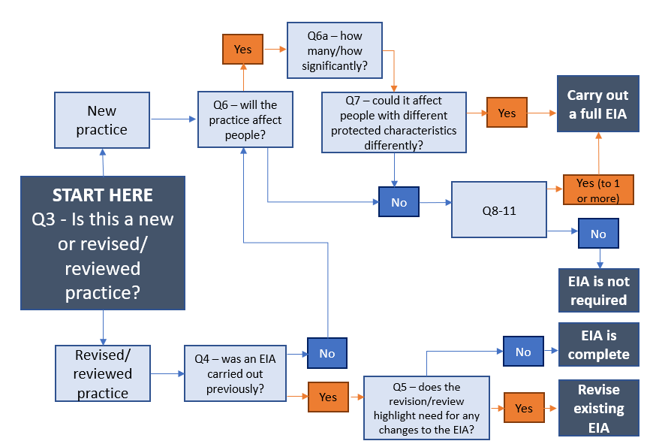
Annex B – Screening Tool Flowchart

